world eer diagram

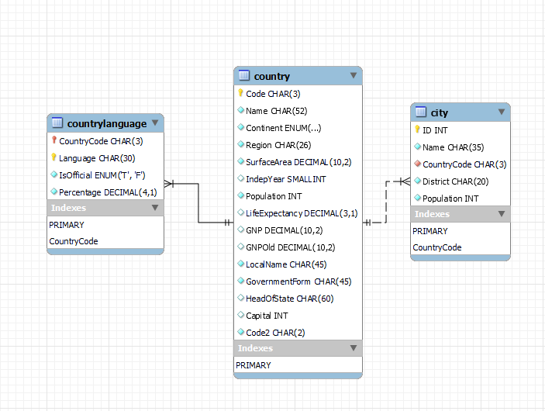

1. **Identify the primary key in country table.**Code CHAR(3)
2. **Identify the primary key in city table.**ID INT
3. **Identify the primary key in countrylanguage table.**Language CHAR(30)
4. **Identify the foreign key in the city table.**CountryCode CHAR(3)
5. **Identify the foreign key in countrylanguage table.**CountryCode CHAR(3)